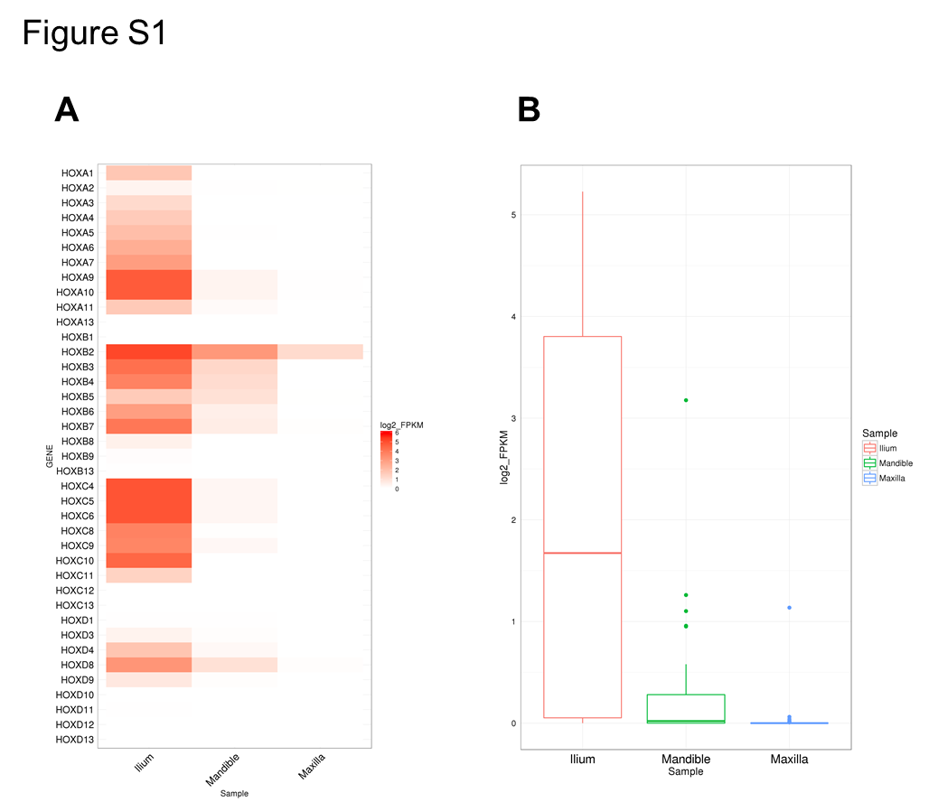
Figure S1 Gene expression profile of all HOX genes in I-MSCs, Mx-MSCs, and Md-MSCs. a Heat map showing the degree of expression levels (log2 of FPKM value) of all HOX genes. b Box plot showing the distribution of expression levels (log2 of FPKM value) of HOX genes (except HOX genes with FPKM = 0 in all samples)

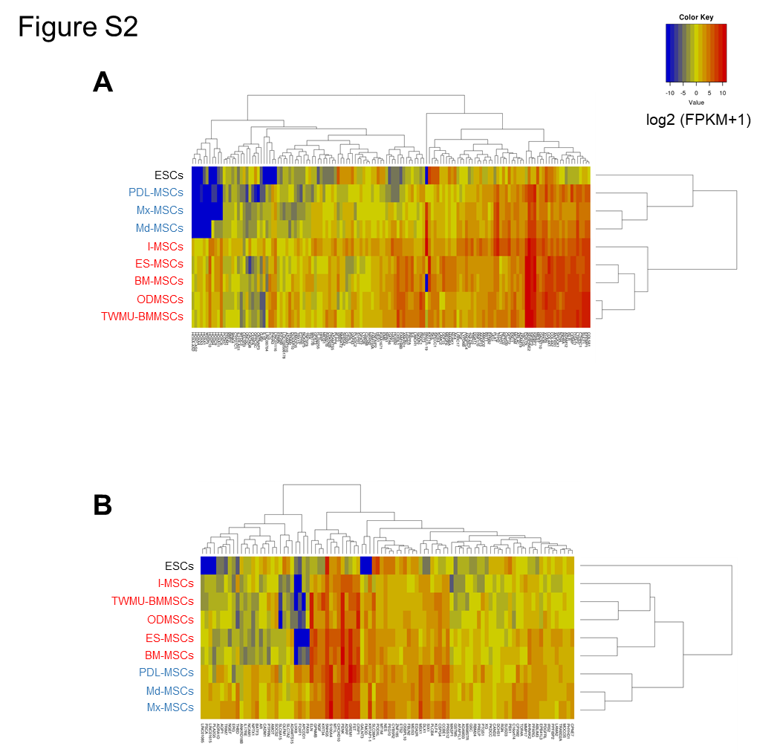
Figure S2 Distinct gene expression patterns between Mfr-MSCs and other cells. a, b Heatmap showing relative expression profiles of U-DEGs (a) and D-DEGs (b). Blue letters represent Mfr-MSCs, and red letters represent other MSCs. Scaled expression values (log2 of [FPKM + 1]) are color-coded according to the legend on the right. Genes are hierarchically clustered by the similarity of their expression profiles over the set of samples, and samples are hierarchically clustered by the similarity of expression patterns over their expression profile

